***Group assignment “Effects of climate change”***

*Introduction:*

We all know a lot about the “greenhouse effect”.

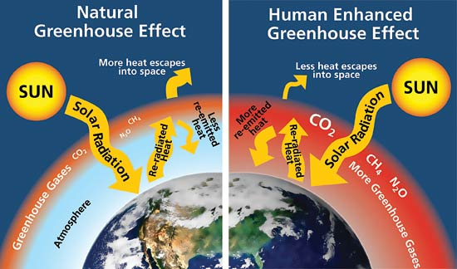

And off course we know that there will be a lot of consequences for our planet and the people who are living on this planet.  
Now we are going to discuss in different groups what these primary effects are, as well as the secundary effects and the effects on residents, buildings and nature.

*Instruction:*

1. Create 10 groups of 4 pupils.

2. Every group gets 6 blue cards with “primary effects”, 10 green cards with “secundary effects” and 11 purple cards with the “effects on residents, buildings and nature”.

3. Discuss with your group how to position the cards in the right way.  
 (cause 🡺 effect)  
Start with the card “Effects of climate change”.

4. To help you a little bit. The structure is like this:

|  |  |  |  |
| --- | --- | --- | --- |
|  | Primary effects | Secundary effects | Effects on residents, buildings and nature |
|  |  |  |  |
|  |  |  |  |
|  |  |  |  |
|  |  |  |  |
|  |  |  |  |
|  |  |  |  |
|  |  |  |  |
|  |  |  |  |
|  |  |  |  |
|  |  |  |  |
| Effects of climate change |  |  |  |
|  |  |  |  |
|  |  |  |  |
|  |  |  |  |
|  |  |  |  |
|  |  |  |  |
|  |  |  |  |
|  |  |  |  |
|  |  |  |  |
|  |  |  |  |
|  |  |  |  |
|  |  |  |  |
|  |  |  |  |
|  |  |  |  |
|  |  |  |  |
|  |  |  |  |

5. Make a picture of your scheme.

Primary effects

higher temperatures  
(heat wave and  
warm winters)

heavy rain

prolonged drought

rising sealevel

rising water   
of the rivers

extreme low discharge   
of rivers

Secundary effects(10)

flooding

heat stress

increased risk of   
floods

moving climate belts and  
change of biodiversity

increased risk of   
floods

enhanced subsidence

salinization and   
fresh water shortage

water quality

fresh water shortage

salinization

Effects on residents, buidings and nature (11) and effects of climate change (1)

effect on bathing water and the ecological quality of water

need for extra   
 water storage

disconnect rainwater

strengthen dunes and dikes, construction of weirs and take care of security

let salt water from the rivers into the polders, which causes more salinization

subsidences of buildings, infrastructure, sewers, agriculture, etc.

floods will damage buildings, land, infrastructure, etc.

vegetation and animals will die because of salt water

need of a good ecological network and corridors

let salt water from the rivers into the polders, which causes more salinization

people need coolness and recreation

effects of climate change